
Solution Architecture

Date | 29 June 2026
Team ID | SWTID-2026-9960
Project Name | OptiCrop: Smart Agricultural Production Optimization Engine
Maximum Marks | 5 Marks

Solution Architecture Diagram:
The solution architecture of the OptiCrop: Smart Agricultural Production Optimization Engine consists of three layers: Presentation Layer, Application Layer, and Data Layer. The Presentation Layer provides a web-based interface for farmers to enter soil parameters and view crop recommendations. The Application Layer contains the Flask API, machine learning prediction engine, authentication service, and optional external APIs. The Data Layer stores the agricultural dataset, trained machine learning model, and prediction records. This architecture ensures efficient, scalable, and accurate crop recommendation services for farmers.

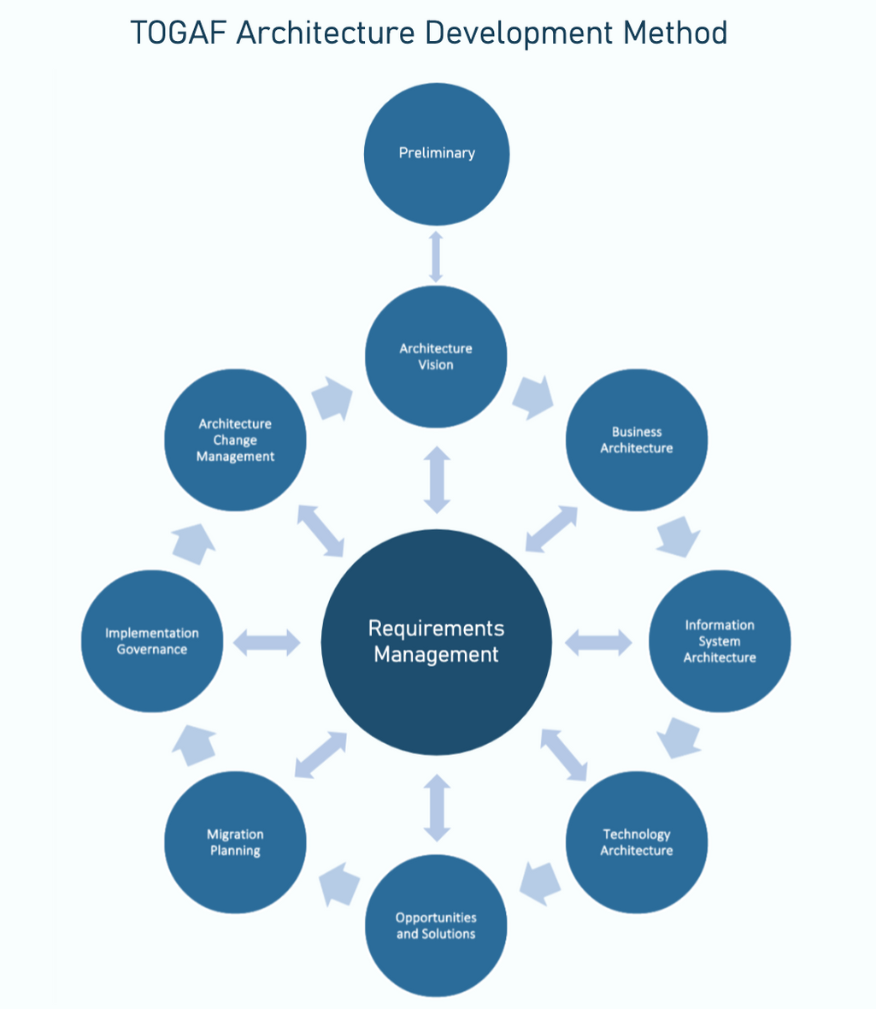


Component Description Table

Component Name | Description / Role in Architecture | Technologies Used
Presentation Layer | Provides user interface where farmers enter soil parameters and view crop recommendations. | HTML, CSS, JavaScript
API Gateway | Receives user requests and sends them to the machine learning algorithms. | Flask REST API
Microservices | Processes soil data and predicts the best crop using machine learning algorithms. | Python, Scikit-learn, Pandas, NumPy
Database | Stores datasets, trained models, and prediction records. | CSV Files, Pickle (.pkl)

